|  |  |
| --- | --- |
| Team ID | PNT2022TMID38891 |
| Project Name | IOT based safety gadget for child safety monitoring & notification |

**Project Design phase-1 solution architecture**

**Solution architecture:**

* + The best tech solution for child safety monitoring would be a system that uses GPS to tack the child’s location,as well as monitoring their activity and alert the parent’s when they are in any danger or abnormal activity.
  + Some characteristics of child safety monitoring gadget:
    - The ability to track the child’s location
    - The ability to monitor the child’s activities
    - The ability to provide emergency assistance to the child and send alert to the parent’s or caregiver if the child wanders out of a designated safe area.
* The device will typically beep or emit some other kind of alert when it detects that a child is in danger.
* Aspects of the project:
  + Our device will help children’s of all ages stay safe while they are outside
  + The devices will use GPS tracking to keep track of the child’s location and
  + Alerts the parents if the child goes outside of a certain radius.
  + The device will also have a panic button that the child can press to alert the parent if they are in danger.
* Features:
  + Live GPS tracking
  + Instant notification to the parent
  + Temperature and heart rate monitor
  + Geo fencing
* Solution requirements:
* The requirement for a child safety monitoring device is that it must be able to track the child’s location, send alert if the child leaves a designated area, and allow the parent to communicate with the child.
* Solution Architecture Diagram:

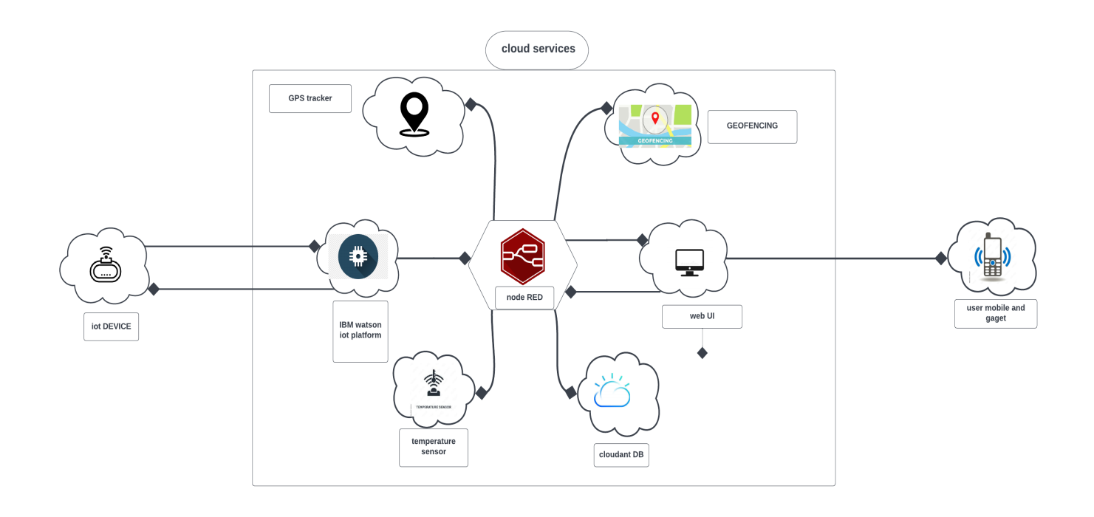

Architecture and data flow of the application